**Data Testing Plan**

**COMP.6210 Web Services & Design Methodologies**

Assignment 02

Submitted by Fernanda Bettega Mairesse

Student ID 300112237

Date: 12th April 2019

Tutor: Jeffrey Kranenburg

**Table of Contents**

[**1.** **DATA TESTING PLAN OUTLINE** 3](#_Toc10750840)

[**2. TEST RECORD SHEET** 4](#_Toc10750841)

[2.1. HOME PAGE 4](#_Toc10750842)

[2.2. SERVICES 6](#_Toc10750843)

[2.3. TESTIMONIALS 12](#_Toc10750844)

[2.4. NEWS 18](#_Toc10750845)

[2.5. CONTACT 24](#_Toc10750846)

[2.6. ABOUT 29](#_Toc10750847)

[2.7. POLICY 32](#_Toc10750848)

[**3.** **TESTER EVALUATION** 35](#_Toc10750849)

# **DATA TESTING PLAN OUTLINE**

The following test plan will evaluate the accuracy of the main features and functionalities of the Neuron’s website from a user perspective. The test outcome of each feature / functionality is split into 3 categories of weighting, being them:

* pass = marked as 10 pts
* pass with restriction = marked as 5 pts
* or fail = marked as 0 pts

As long as there is no major defect in this website, which could strongly affect its quality, the approval threshold is set at 300 pts (about 80% of accuracy) out of 370 pts (100% of accuracy).

This test plan will be executed by the Renato Mairesse Jr, a Senior Full-Stack Developer. After performing all the test steps and giving a weight to each feature / functionality, the tester will issue his final opinion and approve or reprove it based on the approval threshold requirement.

# **2. TEST RECORD SHEET**

The following test record sheets encompass the main features and functionalities expected to each Neuron’s website page. Simultaneously to the tests, the tester should record their outcome, for each of the feature / functionality tested. When the outcome is a fail, or whenever suitable, the tester should add comments to give more details about their finds or to make recommendations.

Weight categories:

* pass = marked as 10 pts
* pass with restriction = marked as 5 pts
* or fail = marked as 0 pts

## 2.1. HOME PAGE

Home page test record sheet:

|  |  |  |  |  |
| --- | --- | --- | --- | --- |
|  | **Test** | **Pass** | **Fail** | **Comments** |
| 1 | Matches the responsive layout – desktop, medium and small devices | 10 |  |  |
| 2 | Navbar links working properly | 10 |  |  |
| 3 | Call to action links working properly | 10 |  |  |
| 4 | No apparent visual defect (i.e. missing image) | 10 |  |  |
| 5 | Forms working as expected | - | - | N/A |
| 6 | Success message of form submission (if applicable) | - | - | N/A |
| 7 | Fail message of form submission (if applicable) | - | - | N/A |

Notes:

1. The steps 1 and 4 (responsive layout and visual defect tests) should be performed to all the 3 layouts.
2. The home page does not contain any form. Therefore, the steps 5, 6 and 7 are not applicable in this case.

**Total: 40 / 40 pts**

**Testing Guidelines**

2.1.1. Desktop layout

**4**

**1**



**3**

**3**

**3**

**3**

**3**

**3**

**3**

**3**

**3**

**2**

**1**

**4**

2.1.2. Small device / mobile phone layout (portrait position)



**2**

**3**

**3**

**3**

**3**

**3**

2.1.3. Medium device / iPad layout (landscape position)

**4**

**1**



**3**

**3**

**3**

**3**

**3**

**3**

**3**

**3**

**3**

**2**

## 2.2. SERVICES

Services pages test record sheet:

|  |  |  |  |  |
| --- | --- | --- | --- | --- |
|  | **Test** | **Pass** | **Fail** | **Comments** |
| 1 | Matches the responsive layout – desktop, medium and small devices | 10 |  |  |
| 2 | Navbar links working properly | 10 |  |  |
| 3 | Call to action links working properly | 10 |  |  |
| 4 | No apparent visual defect (i.e. missing image) | 10 |  |  |
| 5 | Forms working as expected | - | - | N/A |
| 6 | Success message of form submission (if applicable) | - | - | N/A |
| 7 | Fail message of form submission (if applicable) | - | - | N/A |

Notes:

1. The steps 1 and 4 (responsive layout and visual defect tests) should be performed to all the 3 layouts.
2. The service pages do not contain any form. Therefore, the steps 5, 6 and 7 are not applicable in this case.

**Total: 40 / 40 pts**

**Testing Guidelines**

2.2.1. Desktop layout

**1**

**4**

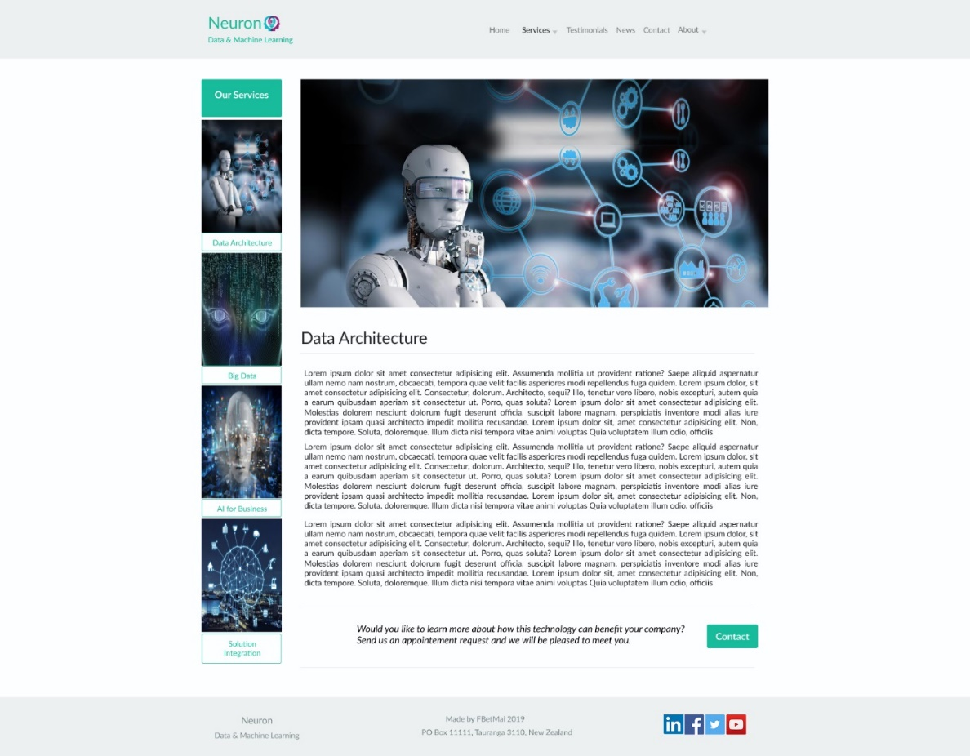

**3**

**3**

**3**

**3**

**3**

**3**

**3**

**3**

**3**

**2**

**3**

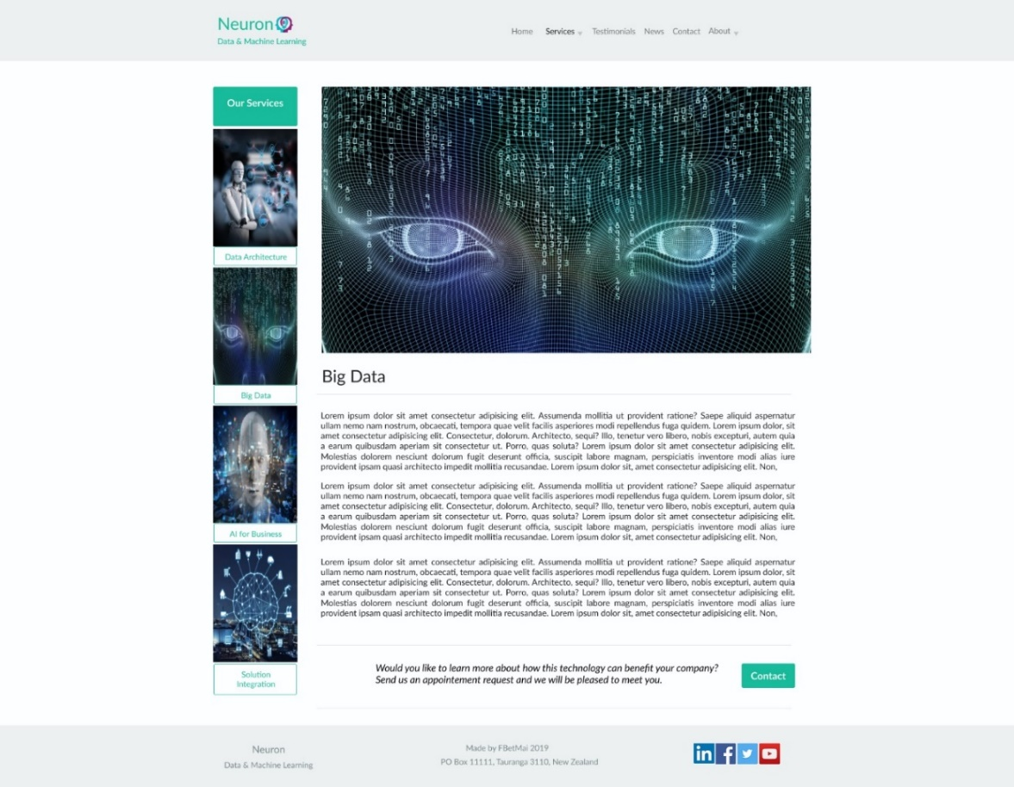

**3**

**3**

**3**

**3**

**3**

**3**

**3**

**3**

**3**

**2**



**3**

**3**

**3**

**3**

**3**

**3**

**3**

**3**

**3**

**3**

**2**

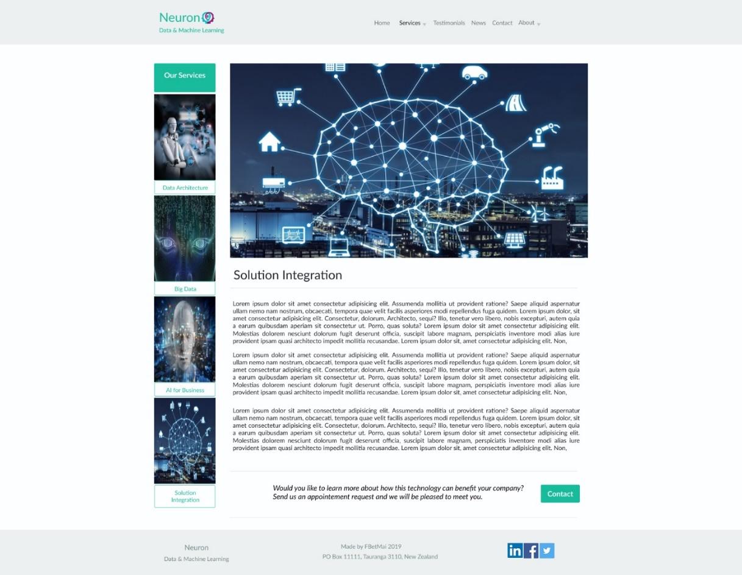

**2**

**3**

**3**

**3**

**3**

**3**

**3**

**3**

**3**

**3**

**3**

2.2.2. Small device / mobile phone layout (portrait position)

**4**

**1**

**2**

|  |  |  |  |
| --- | --- | --- | --- |
| C:\Users\Fernanda\Desktop\6210_Fernanda_30012237\Web Assign1\Images Project\Storyboard\Storyboard Mobile\Services (Data Architecture) Phone.png  **3**  **3**  **3**  **3**  **3**  **3**  **2** | C:\Users\Fernanda\Desktop\6210_Fernanda_30012237\Web Assign1\Images Project\Storyboard\Storyboard Mobile\Services (Big Data) Phone.png  **3**  **3**  **3**  **3**  **3**  **3** | C:\Users\Fernanda\Desktop\6210_Fernanda_30012237\Web Assign1\Images Project\Storyboard\Storyboard Mobile\Services (AI for Business) Phone.png  **3**  **3**  **3**  **3**  **3**  **3**  **2** | C:\Users\Fernanda\Desktop\6210_Fernanda_30012237\Web Assign1\Images Project\Storyboard\Storyboard Mobile\Services (Solution Integration) Phone.png  **3**  **3**  **3**  **3**  **3**  **3**  **2** |

2.2.3. Medium device / iPad layout (landscape position)

**4**

**1**

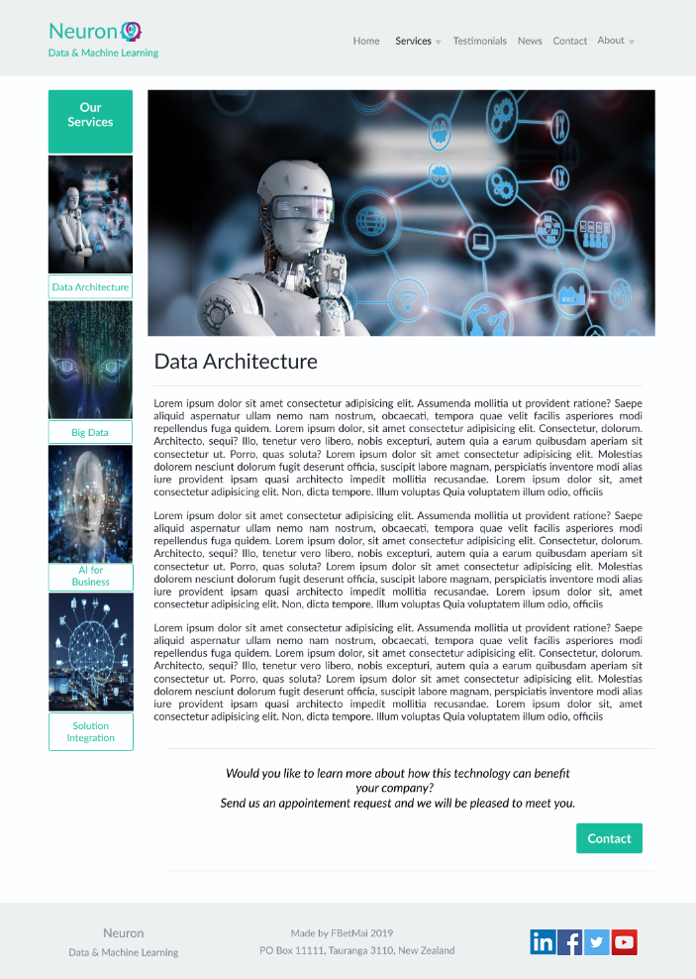

**3**

**3**

**3**

**3**

**3**

**3**

**3**

**3**

**3**

**3**

**2**



**3**

**3**

**3**

**3**

**3**

**3**

**3**

**3**

**3**

**3**

**2**



**3**

**3**

**3**

**3**

**3**

**3**

**3**

**3**

**3**

**3**

**2**



**3**

**3**

**3**

**3**

**3**

**3**

**3**

**3**

**3**

**3**

**2**

## 2.3. TESTIMONIALS

Testimonial page test record sheet:

|  |  |  |  |  |
| --- | --- | --- | --- | --- |
|  | **Test** | **Pass** | **Fail** | **Comments** |
| 1 | It matches the responsive layout – desktop, medium and small devices | 10 |  |  |
| 2 | Navbar links working properly | 10 |  |  |
| 3 | Call to action links working properly | 10 |  |  |
| 4 | No apparent visual defect (i.e. missing image) | 10 |  |  |
| 5 | Forms working as expected | 10 |  |  |
| 6 | Success message of form submission (if applicable) | 10 |  |  |
| 7 | Fail message of form submission (if applicable) | 10 |  |  |

Notes:

1. The steps 1 and 4 (responsive layout and visual defect tests) should be performed to all the 3 layouts.

**Total: 70 / 70 pts**

**Testing Guidelines**

2.3.1. Desktop layout

**4**

**1**

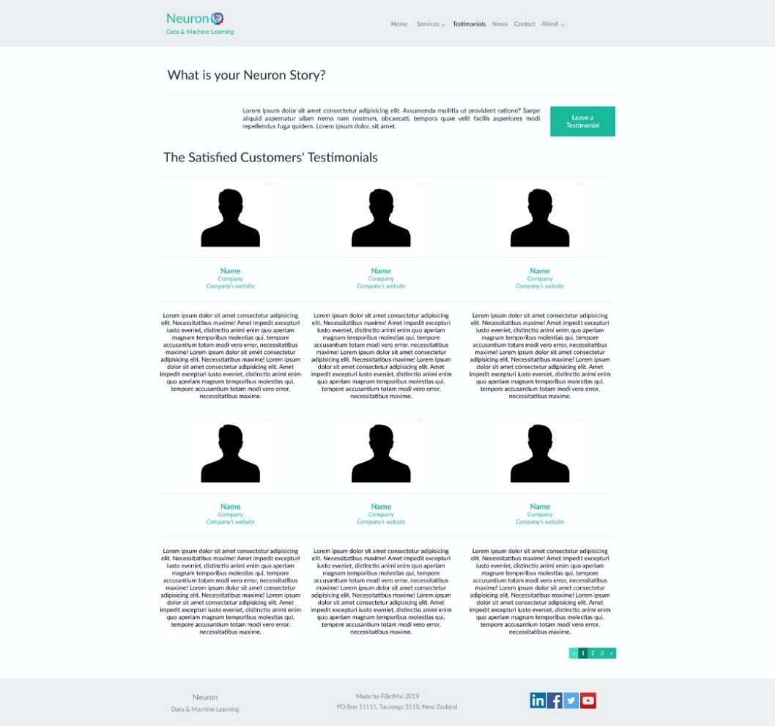

**3**

**3**

**2**

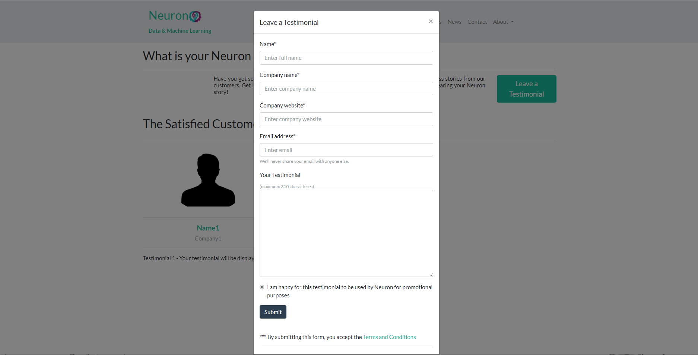

**5**

**3**

**6**

Success message to summited testimonial form



**3**

**3**

**7**

Fail message to summited testimonial form

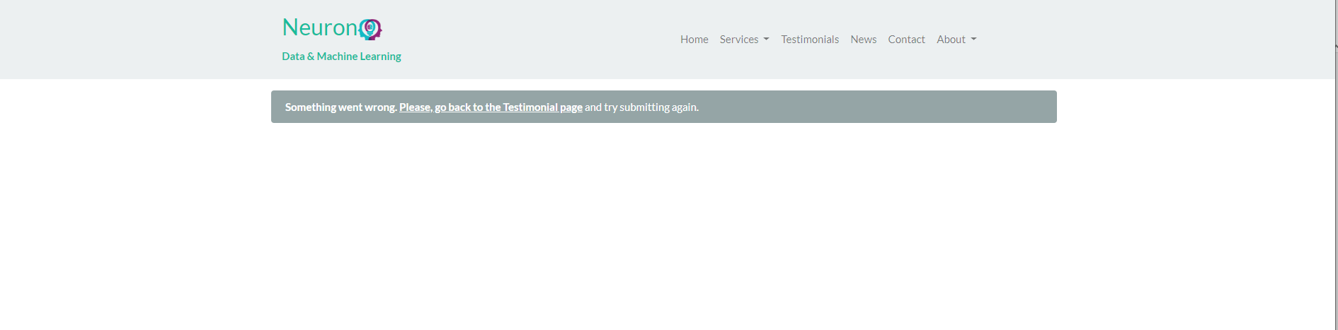

**3**

**3**

2.3.2. Small device / mobile phone layout (portrait position)

**3**

**4**

**1**



**3**

**2**

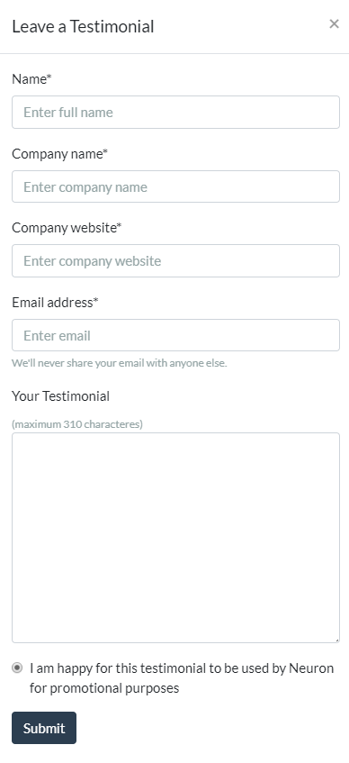

**5**

**3**

**6**

Success message to summited testimonial form



**3**

**3**

**7**

Fail message to summited testimonial form

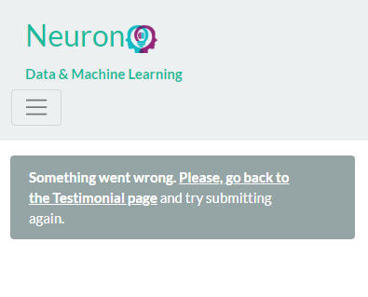

**3**

**3**

2.3.3. Medium device / iPad layout (landscape position)

**1**

**4**



**3**

**3**

**2**

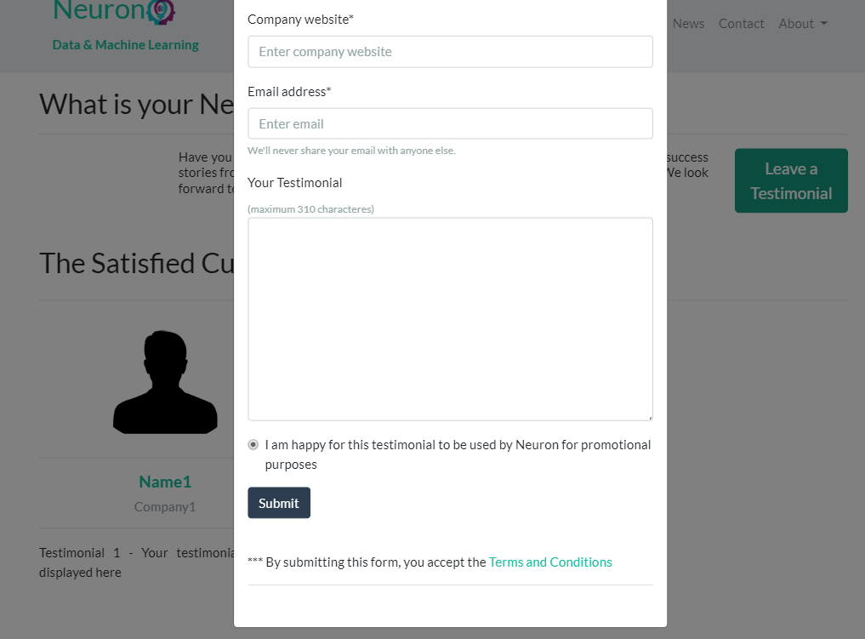

**5**

**3**

**6**

Success message to summited testimonial form



**3**

**3**

Fail message to summited testimonial form

**7**

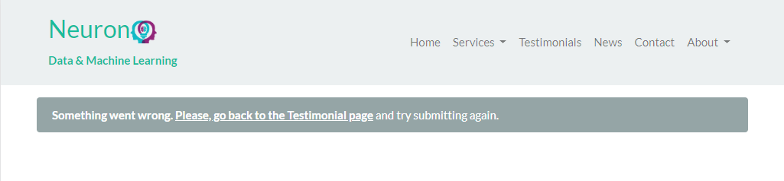

**3**

**3**

## 2.4. NEWS

News page test record sheet:

|  |  |  |  |  |
| --- | --- | --- | --- | --- |
|  | **Test** | **Pass** | **Fail** | **Comments** |
| 1 | It matches the responsive layout – desktop, medium and small devices | 10 |  |  |
| 2 | Navbar links working properly | 10 |  |  |
| 3 | Call to action links working properly | 10 |  |  |
| 4 | No apparent visual defect (i.e. missing image) | 5 |  | Original news website is refusing to connect |
| 5 | Forms working as expected | 10 |  |  |
| 6 | Success message of form submission (if applicable) | 10 |  |  |
| 7 | Fail message of form submission (if applicable) | 10 |  |  |

Notes:

1. The steps 1 and 4 (responsive layout and visual defect tests) should be performed to all the 3 layouts.

**Total: 65 / 70 pts**

**Testing Guidelines**

2.4.1. Desktop layout

**4**

**1**

**3**

**2**

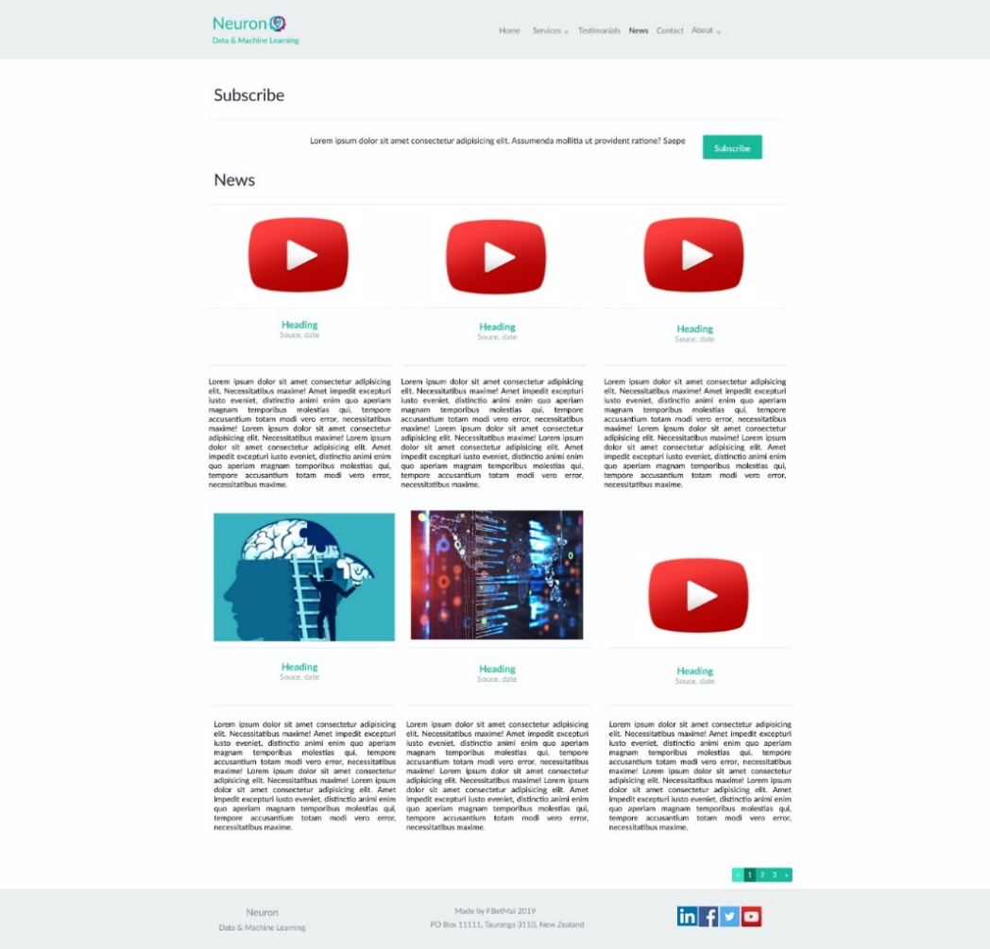

**3**

**3**

**3**

**3**

**3**

**3**

**3**

**3**

**3**

**3**

**3**

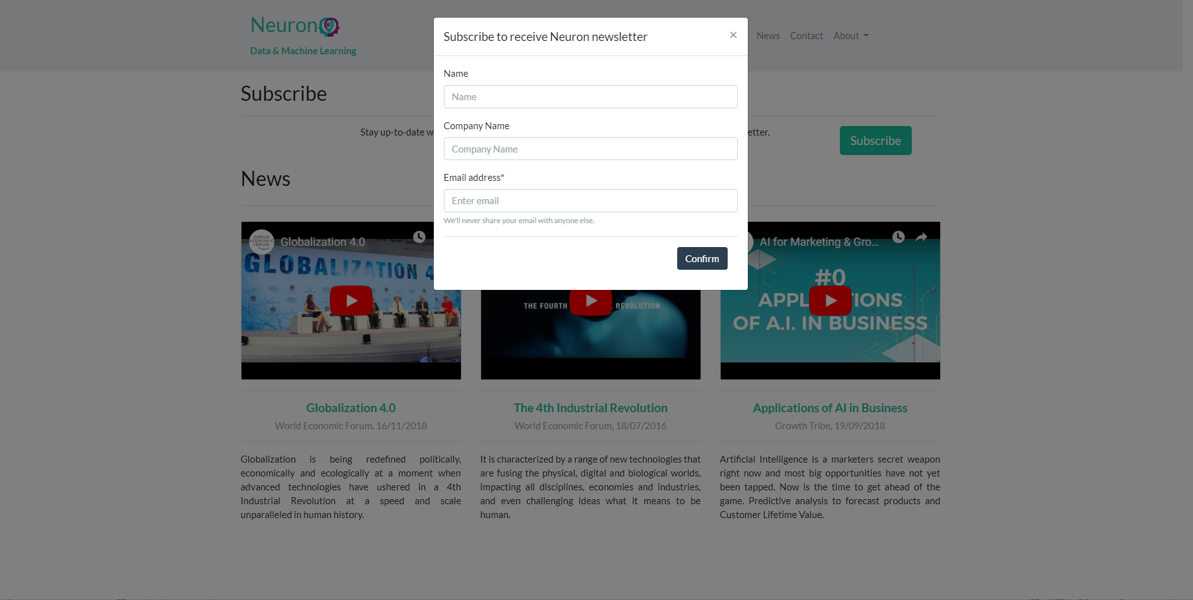

**5**

**3**

**6**

Success message to summited subscribe form

**3**



**3**

**7**

Fail message to summited subscribe form



**3**

**3**

2.4.2. Small device / mobile phone layout (portrait position)

**4**

**1**

**3**



**3**

**3**

**3**

**3**

**3**

**3**

**3**

**3**

**3**

**3**

**3**

**2**

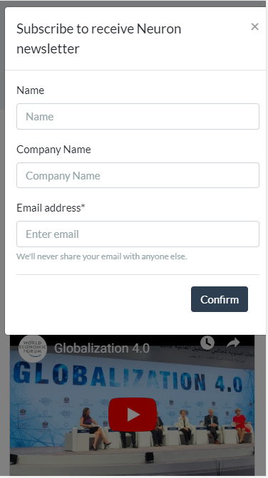

**5**

**3**

**6**

Success message to summited subscribe form



**7**

**3**

**3**

Fail message to summited subscribe form

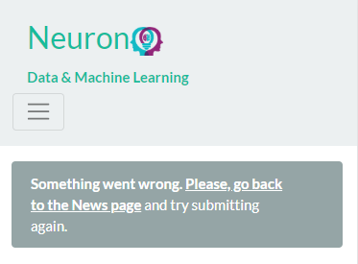

**3**

**3**

2.4.3. Medium device / iPad layout (landscape position)

**4**

**1**

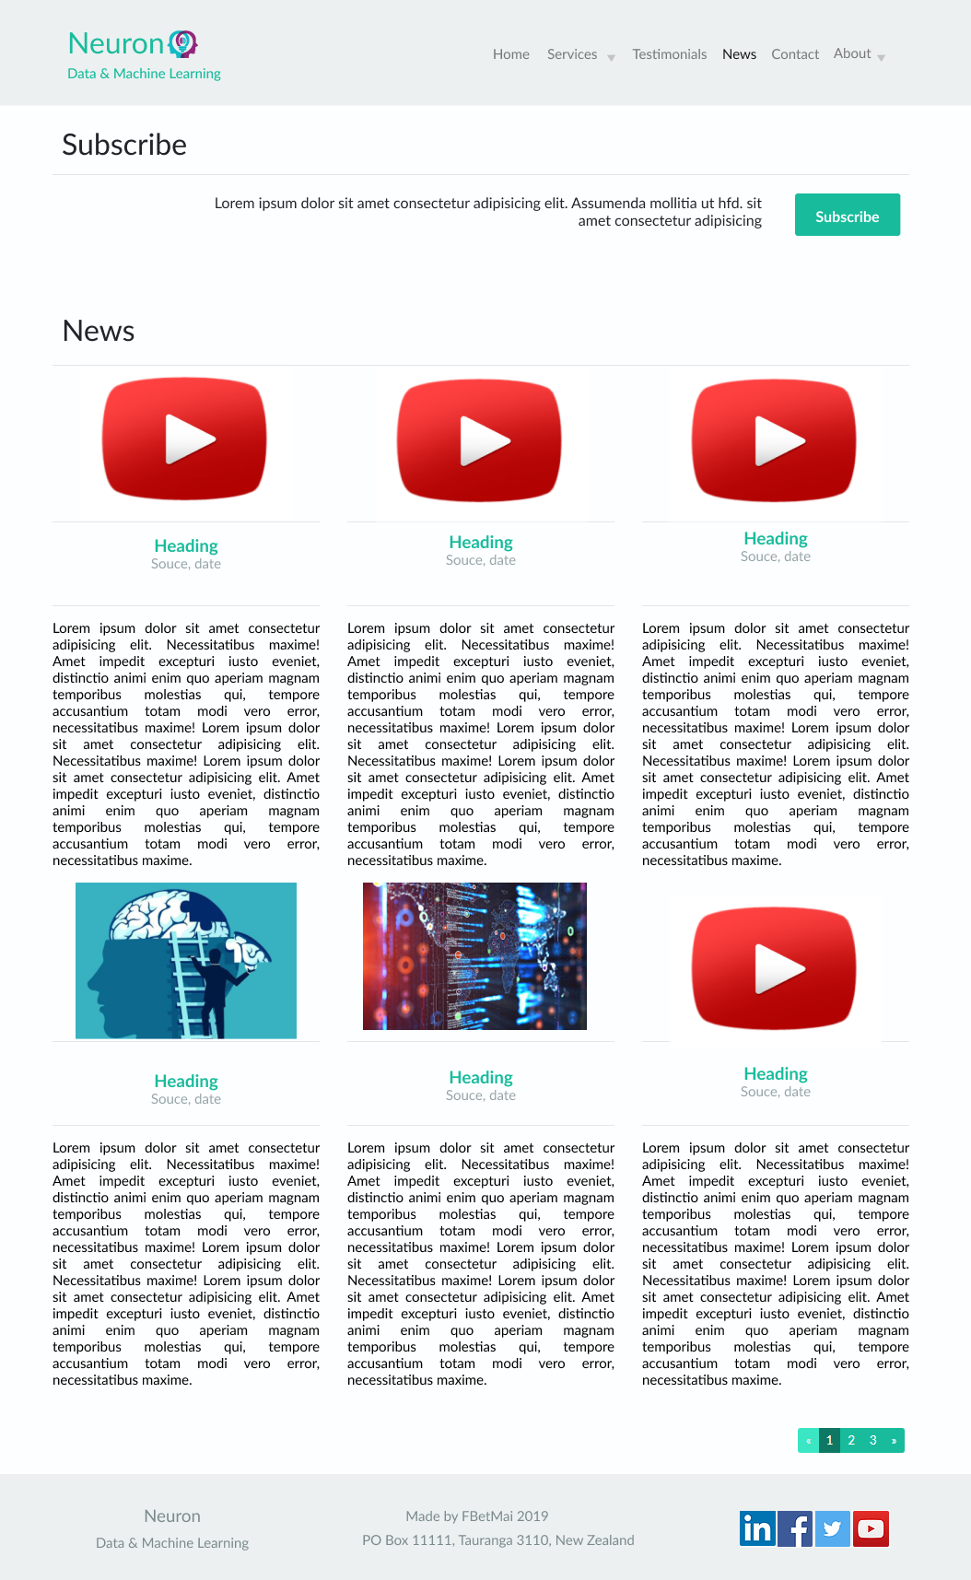

**3**

**3**

**3**

**3**

**3**

**3**

**3**

**3**

**3**

**3**

**3**

**3**

**2**

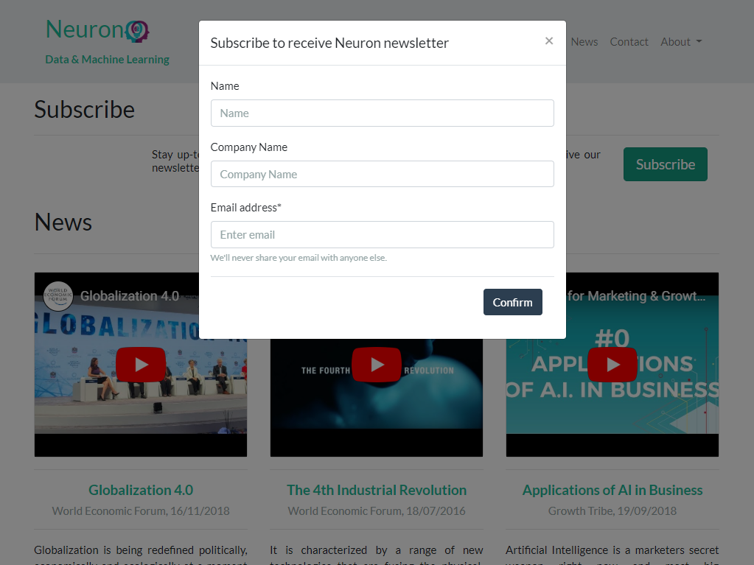

**5**

**3**

**6**

Success message to summited subscribe form



**3**

**3**

**7**

Fail message to summited subscribe form



**3**

**3**

## 2.5. CONTACT

Contact page test record sheet:

|  |  |  |  |  |
| --- | --- | --- | --- | --- |
|  | **Test** | **Pass** | **Fail** | **Comments** |
| 1 | Matches the responsive layout – desktop, medium and small devices | 10 |  |  |
| 2 | Navbar links working properly | 10 |  |  |
| 3 | Call to action links working properly | 10 |  |  |
| 4 | No apparent visual defect (i.e. missing image) | 10 |  |  |
| 5 | Forms working as expected | 10 |  |  |
| 6 | Success message of form submission (if applicable) | 10 |  |  |
| 7 | Fail message of form submission (if applicable) | 10 |  |  |

Notes:

1. The steps 1 and 4 (responsive layout and visual defect tests) should be performed to all the 3 layouts.

**Total: 70 / 70 pts**

**Testing Guidelines**

2.5.1. Desktop layout

**4**

**1**

**2**

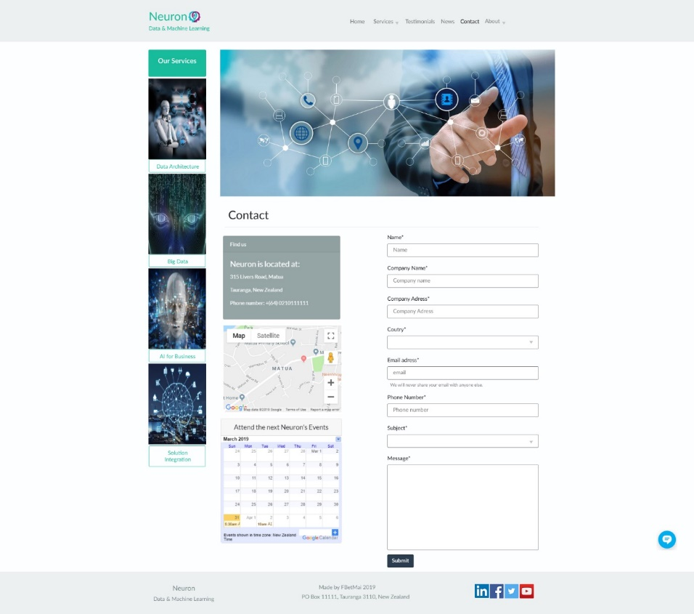

**5**

**3**

**3**

**3**

**3**

**3**

**3**

**3**

**3**

**3**

**3**

**3**

Success message to summited contact form

**6**

**3**



**3**

Fail message to summited contact form

**7**



**3**

**3**

2.5.2. Small device / mobile phone layout (portrait position)

**3**

**4**

**1**



**5**

**3**

**3**

**2**

Success message to summited contact form



**3**

**3**

**7**

Fail message to summited contact form

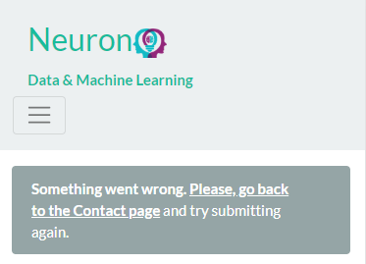

**3**

**3**

2.5.3. Medium device / iPad layout (landscape position)

**4**

**1**

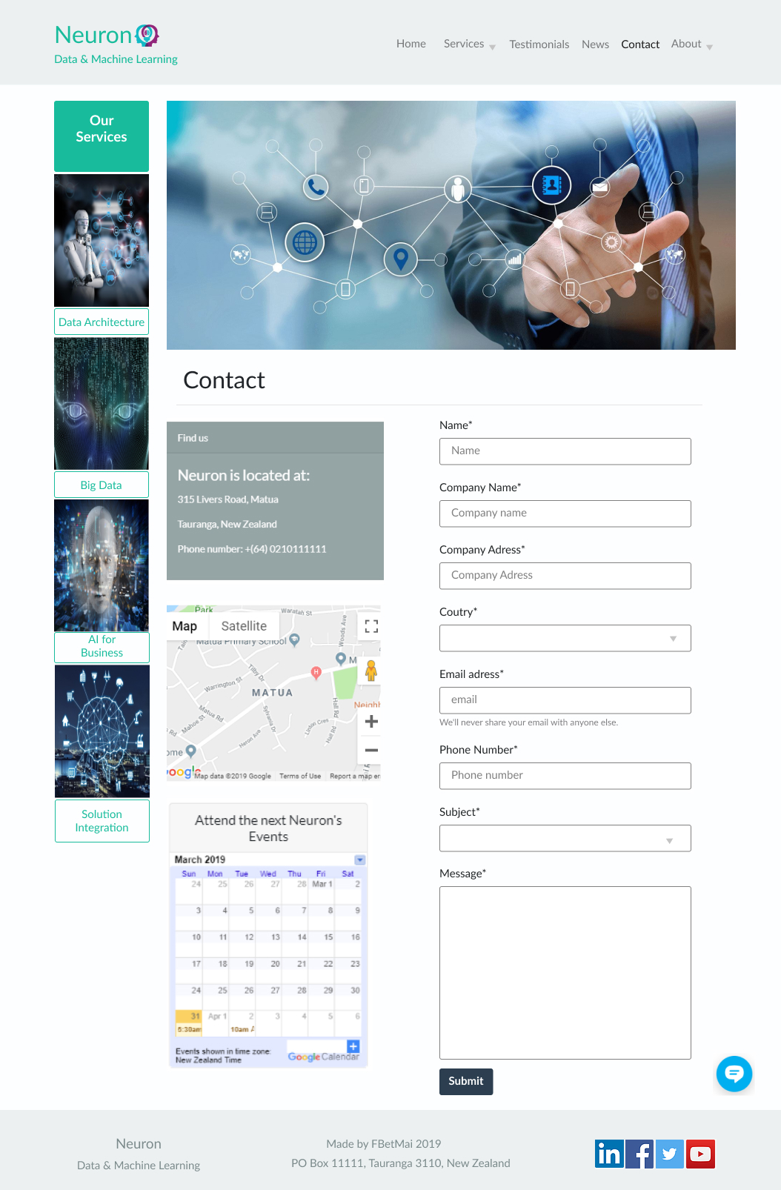

**5**

**3**

**3**

**3**

**3**

**3**

**3**

**3**

**3**

**3**

**3**

**3**

**2**

Success message to summited contact form

**6**



**3**

**3**

Fail message to summited contact form

**7**



**3**

**3**

## 2.6. ABOUT

About page test record sheet:

|  |  |  |  |  |
| --- | --- | --- | --- | --- |
|  | **Test** | **Pass** | **Fail** | **Comments** |
| 1 | Matches the responsive layout – desktop, medium and small devices | 10 |  |  |
| 2 | Navbar links working properly | 10 |  |  |
| 3 | Call to action links working properly | 10 |  |  |
| 4 | No apparent visual defect (i.e. missing image) | 10 |  |  |
| 5 | Forms working as expected | - | - | N/A |
| 6 | Success message of form submission (if applicable) | - | - | N/A |
| 7 | Fail message of form submission (if applicable) | - | - | N/A |

Notes:

1. The steps 1 and 4 (responsive layout and visual defect tests) should be performed to all the 3 layouts.
2. The about page does not contain any form. Therefore, the steps 5, 6 and 7 are not applicable in this case.

**Total: 40 / 40 pts**

**Testing Guidelines**

2.6.1. Desktop layout

**4**

**1**

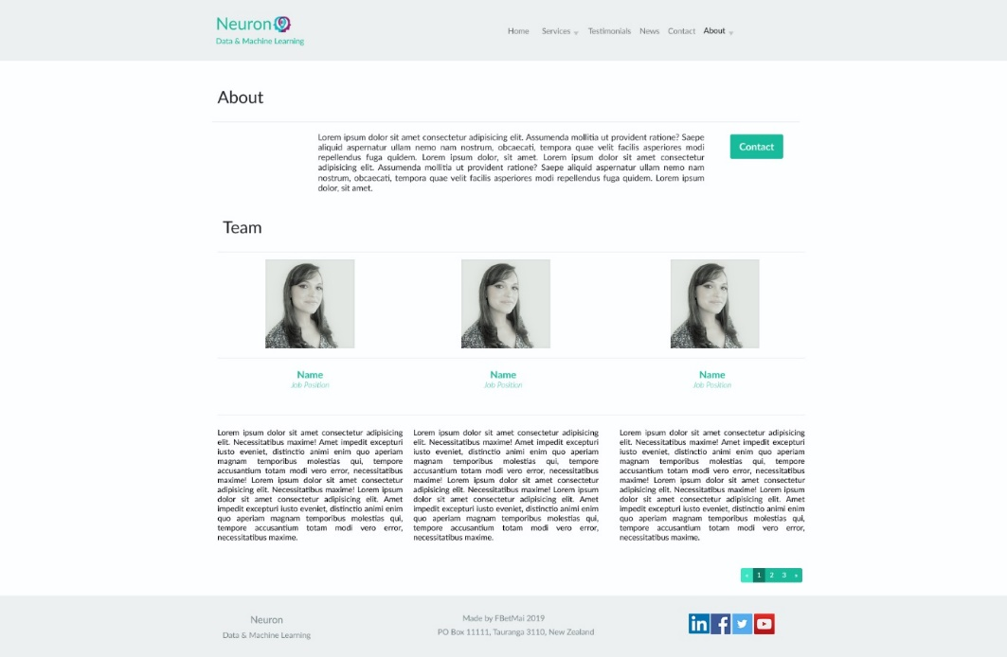

**3**

**3**

**2**

2.6.2. Small device / mobile phone layout (portrait position)

**4**

**1**

**3**

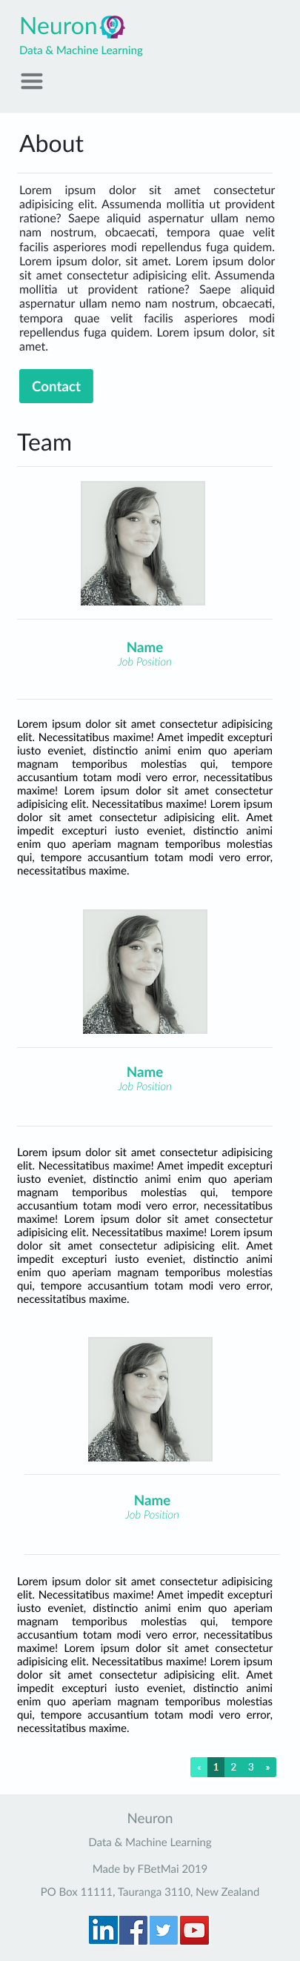

**3**

**2**

2.6.3. Medium device / iPad layout (landscape position)

**4**

**1**

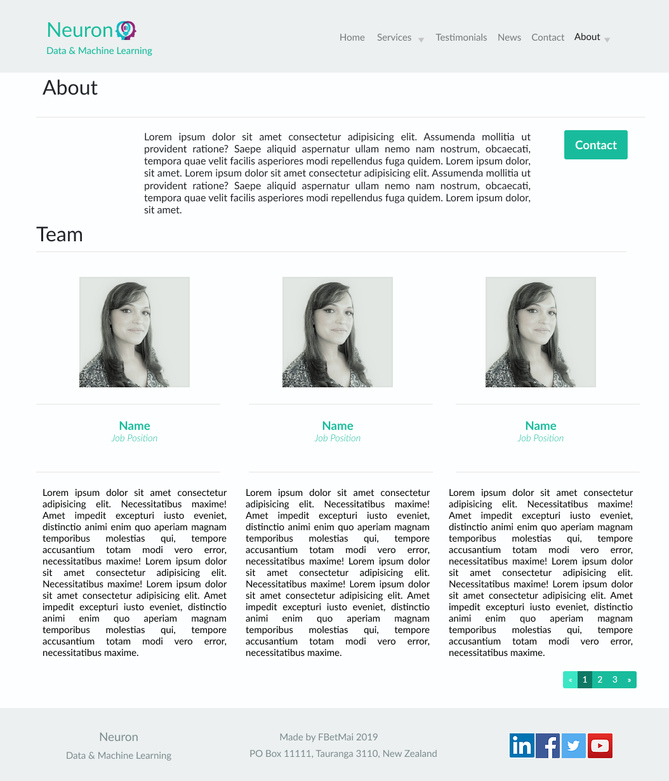

**3**

**3**

**2**

## 2.7. POLICY

Policy page test record sheet:

|  |  |  |  |  |
| --- | --- | --- | --- | --- |
|  | **Test** | **Pass** | **Fail** | **Comments** |
| 1 | It matches the responsive layout – desktop, medium and small devices | 5 |  | Layout different for small device |
| 2 | Navbar links working properly | 10 |  |  |
| 3 | Call to action links working properly | 10 |  |  |
| 4 | No apparent visual defect (i.e. missing image) | 5 |  | Funny question marks in the text |
| 5 | Forms working as expected | - | - | N/A |
| 6 | Success message of form submission (if applicable) | - | - | N/A |
| 7 | Fail message of form submission (if applicable) | - | - | N/A |

Notes:

1. The steps 1 and 4 (responsive layout and visual defect tests) should be performed to all the 3 layouts.
2. The policy page does not contain any form. Therefore, the steps 5, 6 and 7 are not applicable in this case.

**Total: 30 / 40 pts**

**Testing Guidelines**

2.7.1. Desktop layout

**4**

**1**

**3**

**2**

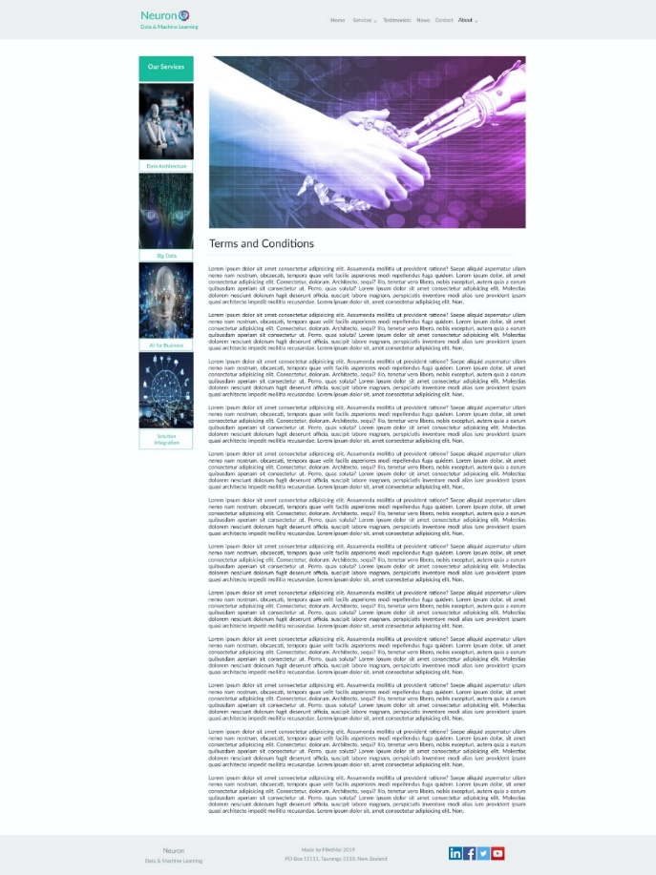

**3**

**3**

**3**

**3**

**3**

**3**

**3**

**3**

2.7.2. Small device / mobile phone layout (portrait position)

**4**

**1**

**3**



**2**

2.7.3. Medium device / iPad layout (landscape position)

**1**

**4**

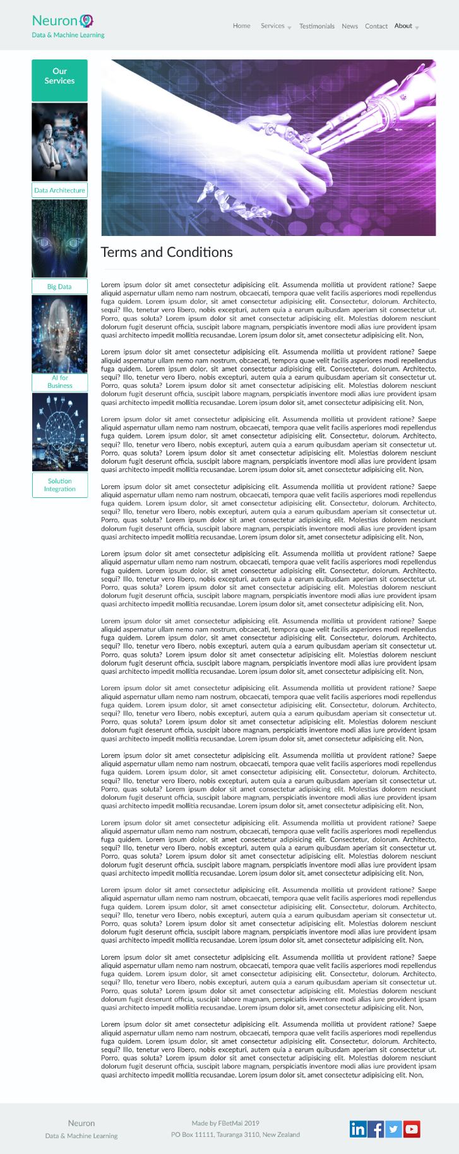

**3**

**3**

**3**

**3**

**3**

**3**

**3**

**3**

**3**

**2**

# **TESTER EVALUATION**

The tester’s final opinion is as per below:

1. No major defect was found in this website. Its quality is, in general, acceptable in terms of visual design and functionalities meet expectations.
2. The total sum of the test outcome achieved 355 pts out of 370 pts. It represents 96% of accuracy. Therefore, it meets the approval threshold (> 300 pts).
3. Points of improvements:

* **News page**: it is missing one of the news images and a message of error is showing up.
* **Policy page**: It is showing a slightly different layout for small devices. While there are services buttons in this website, no button was supposed to exist based on its original design. Additionally, there ae some funny question marks throughout the text which need to be cleared.

Final result of this test:

|  |  |
| --- | --- |
| X | Approved |
|  | Reproved |

**Renato Mairesse Junior.**

**Tauranga, 06th of June.**